Project Name | Tichi Web Application

Document Name | Bug Report
Version | 1.0

Created By | Rohit K

Created Date | 03-07-2026

Reviewed By

Bug Report 1

Responsive UI layout issue across the application

Bug ID: BUG_001
Title: Landing page is not responsive at reduced browser width
Module: Landing Page
Severity: Medium
Priority: Medium
Environment:
- OS: Linux
- Browser: Firefox
- URL: https://tichi-app-webapp-stage.web.app/login
Preconditions:
- Login page is open.
Steps to Reproduce:
- Open the Login page.
- Reduce the browser width (or test on tablet/mobile viewport).
- Observe the page layout.
Expected Result:
The layout should adjust to the viewport without excessive empty space, clipping, or horizontal scrolling.
Actual Result:
The layout does not adjust correctly and leaves excessive blank space, reducing usability.
Status: Open
Affected Pages:
- Landing Page
- Login Page
- Sign Up Page
- Forgot Password Page
Evidence:
Landing Page

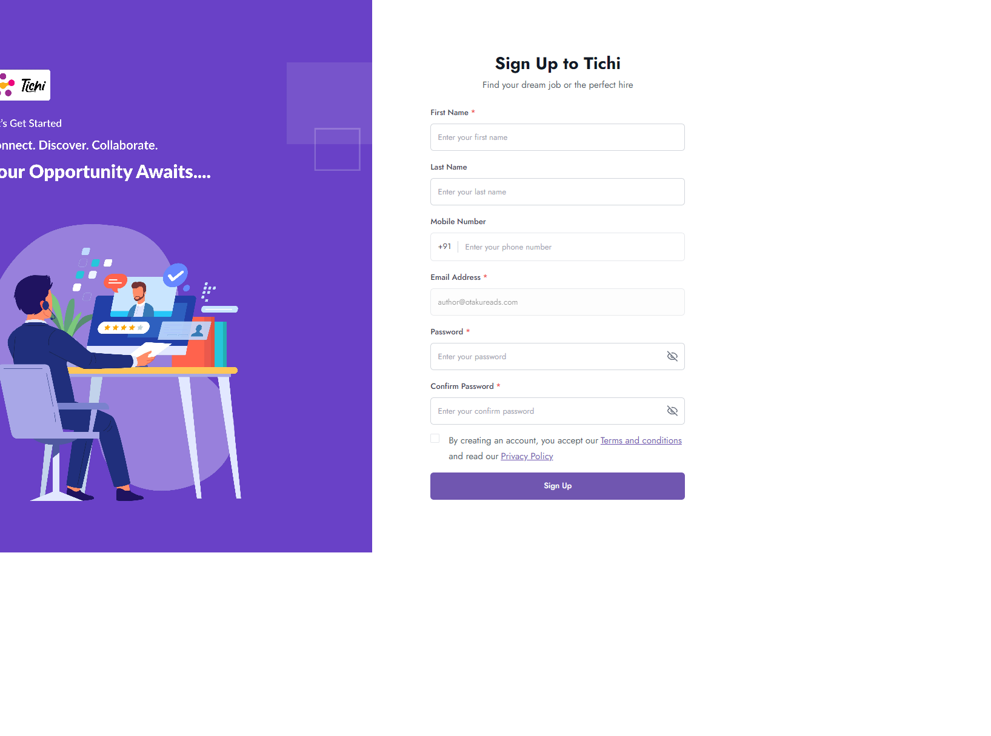

Bug ID: BUG_002
Title: Unregistered email redirects to Sign Up page and allows account creation without clear registration flow
Module: Login / Sign Up
Severity: High
Priority: High
Status: Open
Preconditions
- User is on the Login page.
Steps to Reproduce
- Open the Login page.
- Enter an unregistered but valid email address (e.g., author@otakureads.com).
- Click Continue.
- Enter the required signup details and any valid password.
- Click Sign Up.
Expected Result
The application should clearly indicate that the email is not registered and explicitly guide the user to the registration process. The transition between login and registration should be clear and intentional.
Actual Result
The application redirects directly to the Sign Up page and allows the user to register the account after entering the required details, without clearly indicating that the login flow has switched to registration.

Evidence:
Sign-Up Page

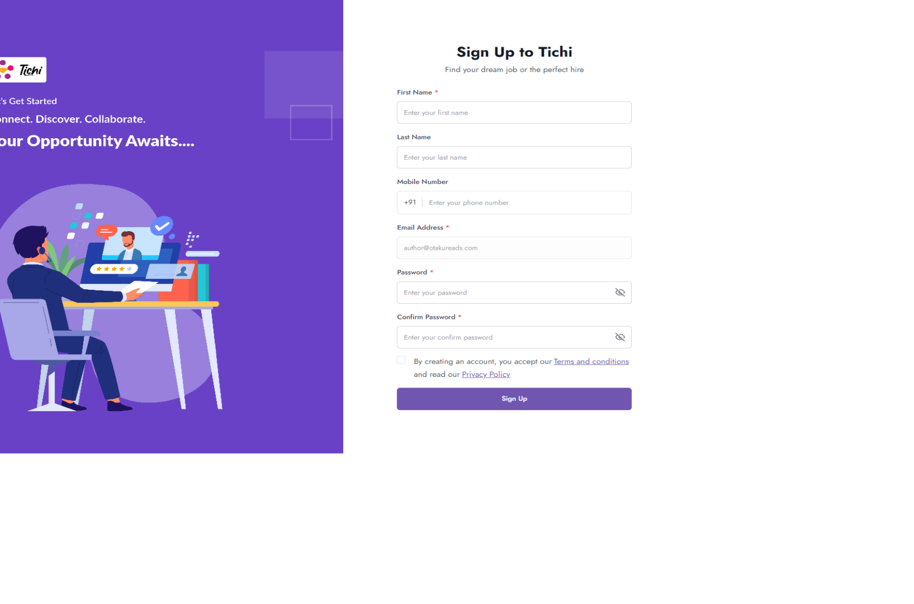

Bug ID: BUG_003
Title: User email address is exposed in the Forgot Password URL
Module: Forgot Password
Severity: Medium
Priority: Medium
Category: Security / Privacy
Status: Open
Preconditions
- User is on the Login page.
- A valid email address has been entered.
Steps to Reproduce
- Open the Login page.
- Enter a valid registered email address.
- Click Continue.
- Click Forgot Password.
- Observe the browser URL.
Expected Result
The Forgot Password page should open without exposing the user's email address in the URL. Sensitive information should be maintained in the application state, session, or passed securely.
Actual Result
The email address is included in the URL as a query parameter.
Example:
/forgot-password?email=rohitk06102005%40gmail.com
Evidence:
ForgotPassword Page

